Subject Name: Source Code Management
Subject Code: 22CS003
Session: 2022-23
Department: DCSE

Submitted To:
Dr. Prabhjot Kaur Chahal
Submitted By:
Gurmehak Kaur
220990342- First Year
G23-A

INDEX

S. No. | PROGRAM TITLE | PAGE NO.
1. | Setting up of Git Client | 1-2
2. | Setting up GitHub Account | 3-4
3. | Generate logs | 5-7
4. | Create and visualize branches | 8-9
5. | Git life cycle description | 10-11
LIST OF PRACTICALS OF TASK 1.1


PRACTICAL- 1

AIM: Setting up of Git client

What is Git?
Git is a DevOps tool used for source code management. It is a free and open-source version control system (VCS) used to handle small to very large projects efficiently.

STEP-1: Browse to the official website: https://git-scm.com/downloads and select Windows.

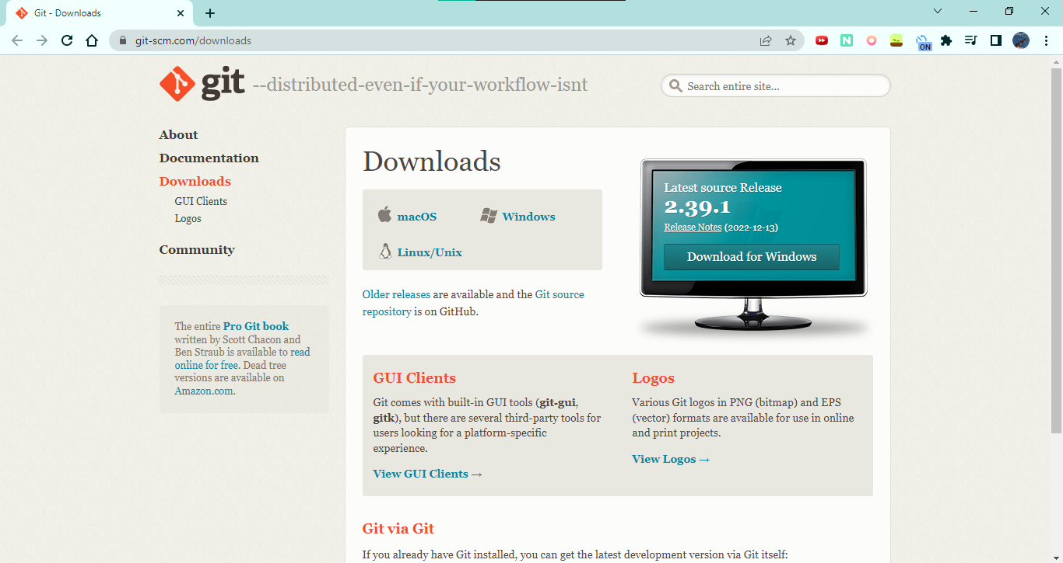

STEP-2: Install the latest version of Git.

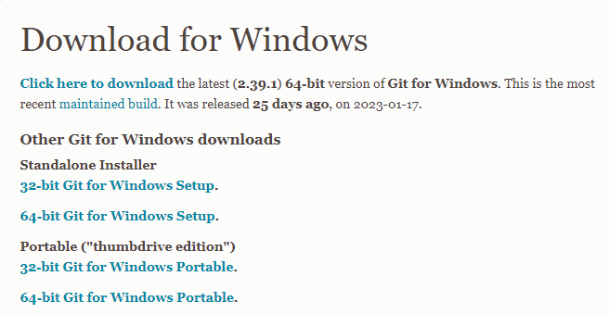

STEP-3: After the file is downloaded, install it in the system.

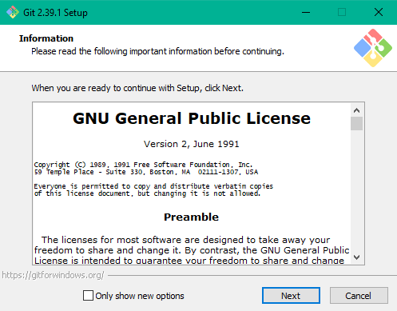
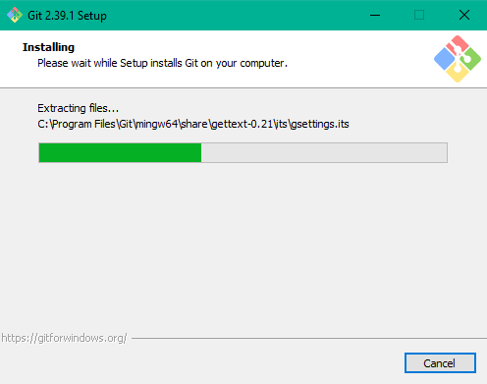
STEP-4: Click on Launch Git Bash and finish. Git bash has been successfully installed.

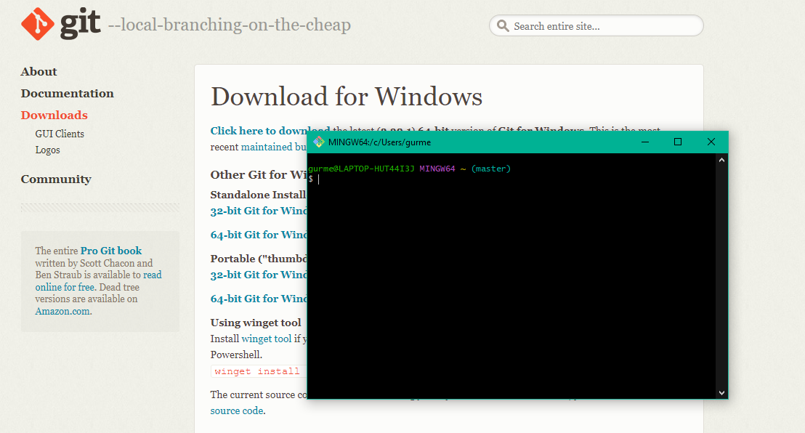

STEP-5: Check the Git version:

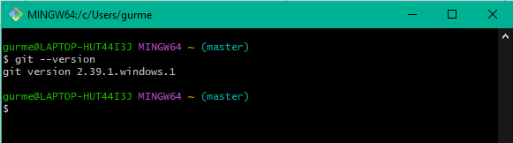


PRACTICAL- 2

AIM: Setting up a GitHub account.

THEORY:
- What is GitHub?
- Difference between Git and GitHub
- GitHub account setup
GitHub: GitHub is the largest host of source code in the world, and has been owned by Microsoft since 2018. It’s an online database that allows you to keep track of and share your Git version control projects outside of your local computer/server. Unlike Git, GitHub is exclusively cloud-based. Basically,
Git is the tool, GitHub is the service for projects that use Git.
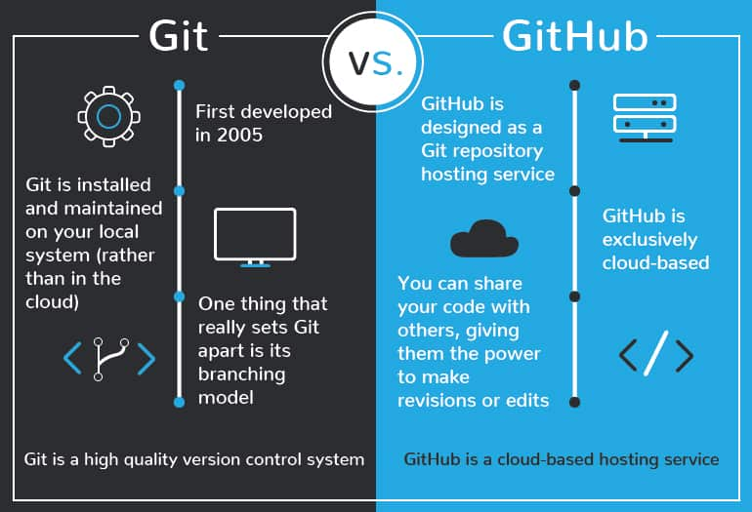
GitHub Account Setup:
STEP-1: Go to https://github.com/ on any browser and click on Sign up. Enter your email id and create a strong password.
STEP-2: Enter a unique username.
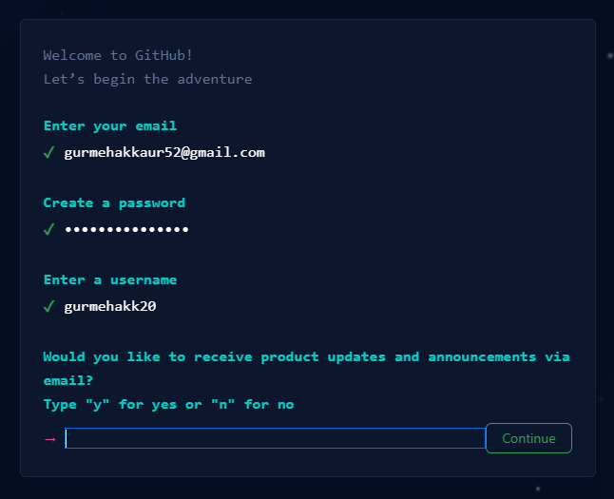
STEP-3: Follow the prompts and click on Create Account.
STEP-4: Verify your account by entering the launch code sent on your email.

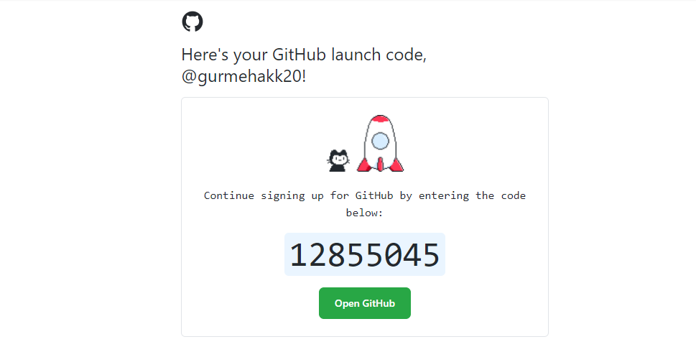

STEP-5: Different plans are offered by GitHub. Select the Free plan and click on continue for free.

PRACTICAL- 3

AIM: Generate logs.

SOFTWARE REQUIRED: Git

THEORY: There are various git commands: pwd, git –version, git init, Significance of .git folder, ls -la, git config --global user email, git config --global user.name, git status, git add, git commit, git checkout, git log, etc.

WORKING WITH GIT:

pwd stands for present working directory which tells us about on which directory we are currently, it shows in form of path.



git –version tells us about the current version of git installed in our system



init- Create an empty Git repository or reinitialize an existing one.



-

git branch



git status
To check the status of files like which file is modified, untracked, tracked files etc..
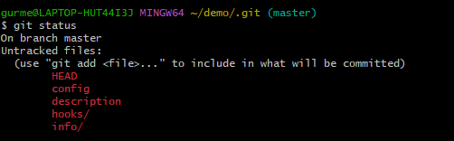

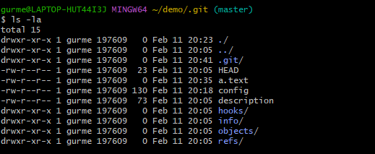

config enters user information to git

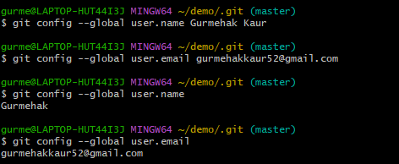

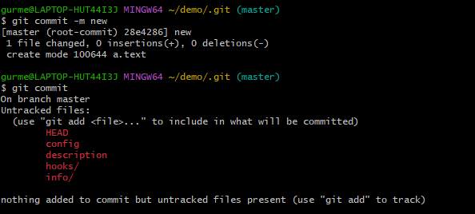
If you are having trouble remembering commands you can use help command.

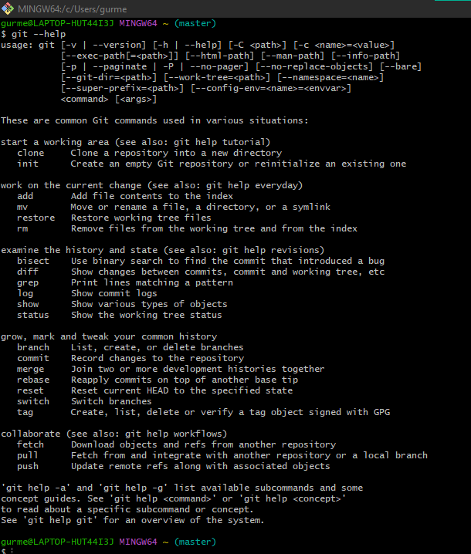

git log

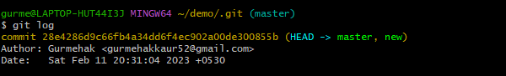

- Git log is a utility tool to review and read a history of everything that happens to a repository.
- It shows a list of all the commits made to a repository.
- It also shows hash, author info, and message of each commit.

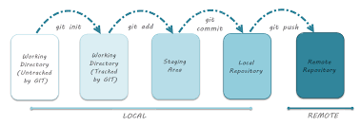

PRACTICAL- 4:

AIM: Create and visualise branches

SOFTWARE REQUIRED: Git

THEORY:

Branching meaning in git:

- While working on real time projects code base, branching is one of mandatory and unavoidable concept.
- Till now whatever files created and whatever commits we did, all these happened in master branch.
- Master branch is the default branch/ main branch in git. Generally main source code will be placed in master branch.

Need of creating branch:

Assume we required to work on new requirements independently, then instead of working in the master branch, we can create a separate branch and we can work in that branch, related to that new requirement without affecting main branch.

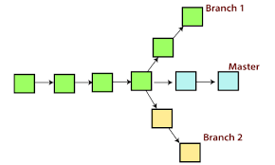
Branch

Creating new branch:



To View list of all available branches:

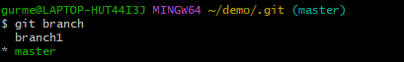
To navigate to a branch:



To create and navigate a branch:

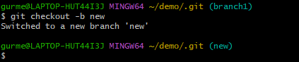

Delete branch:
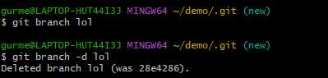

Merging of branch :

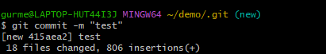


IMPORTANCE OF BRANCHING:

Branching is used in version control and software management to maintain stability while isolated changes are made to code. Branching facilitates the development of bug fixes, the addition of new capabilities and the integration of new versions after they have been tested in isolation.

PRACTICAL- 5:

AIM: Git lifecycle description.

THEORY:

The three stages of Git:
- Untracked
- Staged
- Committed

In a Git repository, files pass through the following stages:
- When you first create a file in the working tree, Git notices it and tells you there's a new untracked file which Git has never seen before.
- When you add it, it becomes a tracked file.
- If you commit the file, then it goes in an unmodified state; this means Git knows it, and the current version of the file in the working tree is the same as the one in the HEAD commit.
- If you make some changes, the file goes to a modified state.
- Adding a modified file to the staging area makes it a staged file.

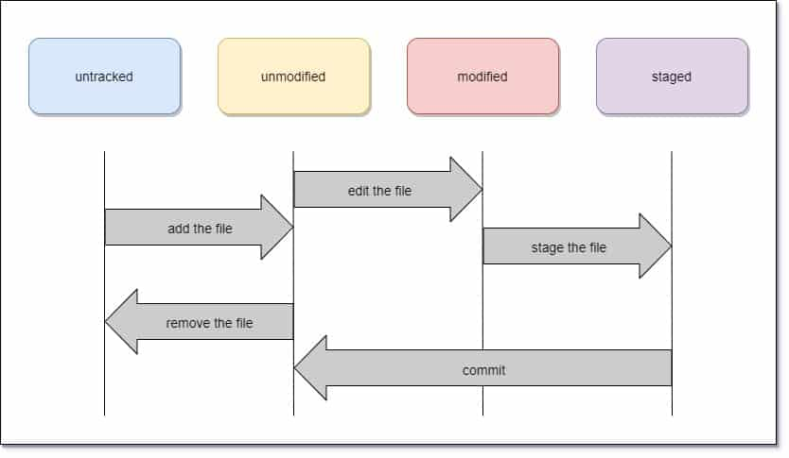

The following table summarizes the different git levels and commands involved in the workflow:

